Student worksheet

6.1 All living things are made up of cells

Pages 96–97 and 196

Cells

1 Who made one of the first microscopes?

2 What did this scientist discover by looking at cork?

3 What scientific field of study did this scientist create in their work?

4 What are the three principals of cell theory?

5 What is a unicellular organism? Give an example.

6 What is a multicellular organism? Give an example.

7 What is the function of the membrane of a cell?

8 How does a cell maximise the function of the cell membrane

9 What is the relationship between the amount of surface area and the volume of a cell called?

10 Explain why smaller cells are better able to survive.

11 Which of the cells below has a larger surface area to volume ratio? Explain your answer.

a 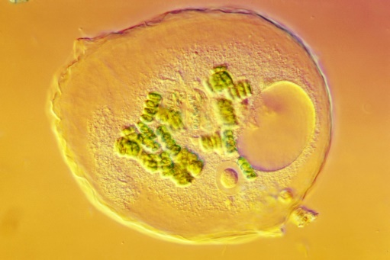 b 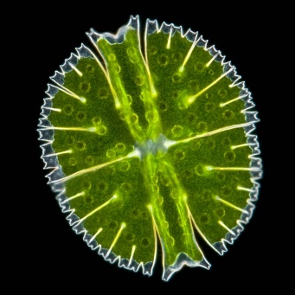

Extend your understanding

12 A cube with 4 cm base, height and width is shown in diagram a. Diagram b shows the same cube cut into 8 identical cubes, each with a 2 cm base, height and width.

a b

Formulas for a cube:

Surface area (*SA*) = 6 × (base × height)

Volume (*V*) = base × height × width

Use the given formulas to answer the following questions.

a Calculate the surface area of the larger cube (diagram a)

b Calculate the volume of the larger cube (diagram a)

c Calculate the combined surface area of the 8 smaller cubes (diagram b)

d Calculate the combined volume of the 8 smaller cubes (diagram b)

e Which has a larger volume?

f Which has a larger surface area?

g Which would be more effective at absorbing nutrients? Explain your answer.

Student worksheet

6.2 Microscopes are used to study cells

Pages 98–99 and 197

Microscopes

1 Label the parts of this microscope in the spaces provided.

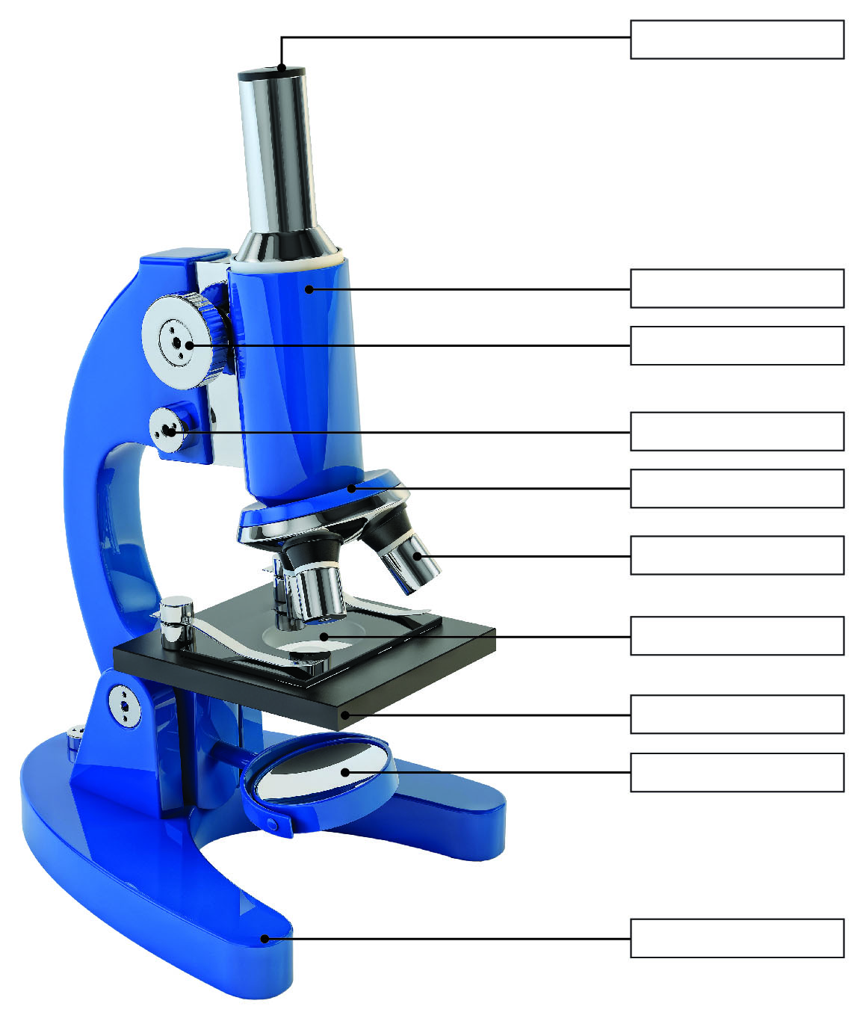

2 What are the three types of microscopes?

3 Why are there three objective lenses on a compound light microscope?

4 Complete the table below to summarise the main differences between the three types of microscopes.

|  |  |  |  |
| --- | --- | --- | --- |
|  | Compound Light Microscope | Stereo Microscope | Scanning Electron Microscope |
| What is it used to observe? |  |  |  |
| What is its magnification? |  |  | 1–50 million times |
| DIMENSION |  |  | 3D image |
| Can it see through an object or only the surface? |  |  |  |
| Can it be used to see cells or whole organisms? |  |  |  |

Extend your understanding

5 Complete the following magnification calculations.

a eyepiece magnification 10, objective lens 10

b eyepiece magnification 10, objective lens 20

c eyepiece magnification 10, objective lens 40

6 What happens to the magnification of the microscope as you double the objective lens magnification?

7 Complete the following magnification calculations.

a eyepiece magnification 10, objective lens 10

b eyepiece magnification 5, objective lens 10

c eyepiece magnification 10, objective lens 20

c eyepiece magnification 5, objective lens 20

8 What happens to the magnification of the microscope as you halve the ocular lens magnification?

Student worksheet

6.3 Plant and animal cells have organelles

Pages 100–103 and 198-200

Cell organelles

1 What is a cellular organelle? Give an example and state its function.

2 What is the function of the following cellular structures?

a cell membrane

b cytoplasm

c DNA

3 Label the organelles in the animal cell below.

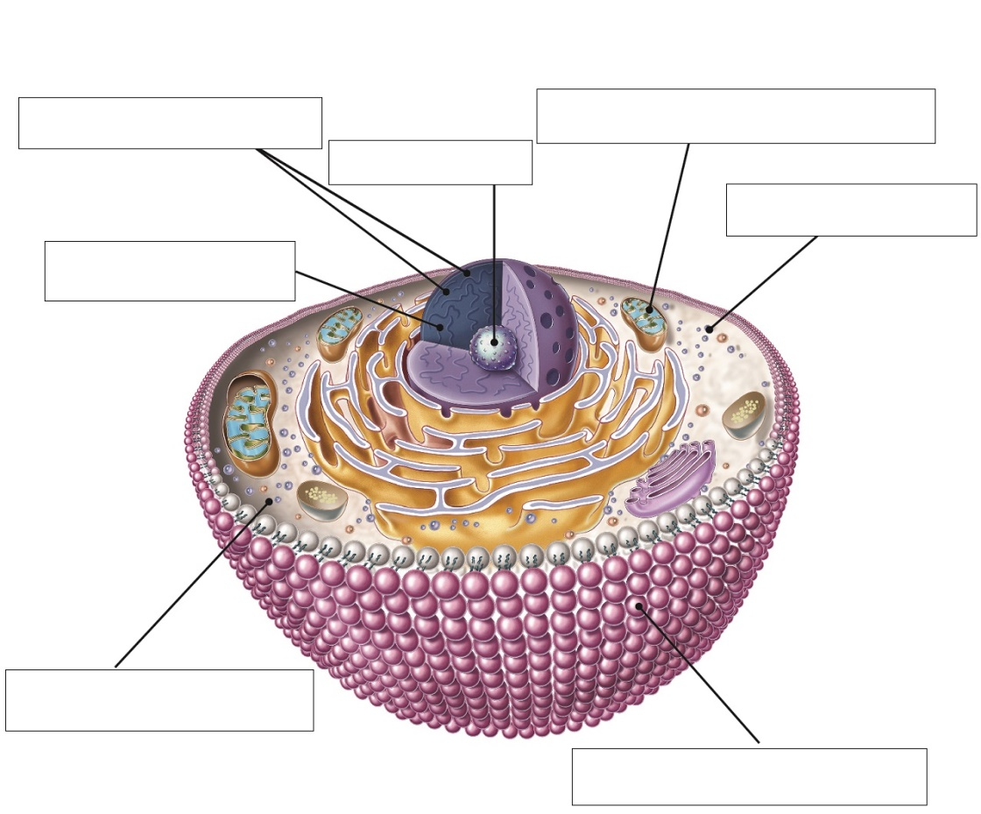

4 Label the organelles in the animal cell below.

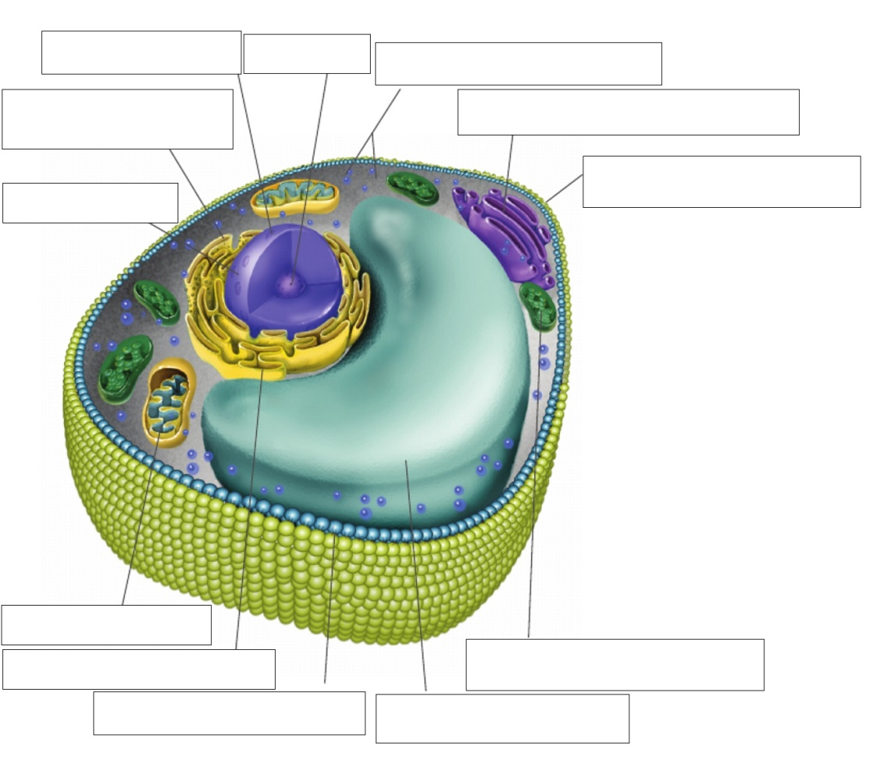

5 Complete the following Venn diagram by identifying which organelles belong to plants, animals or both.

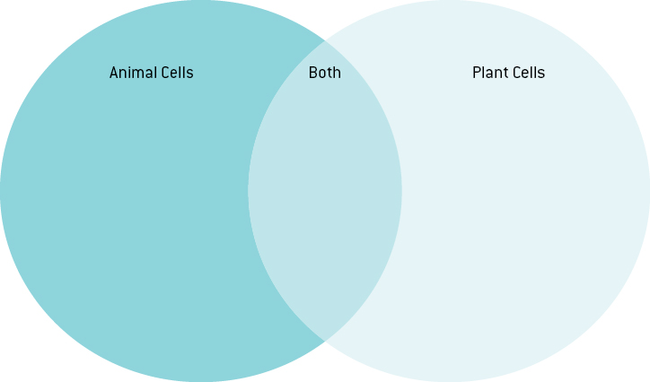

Extend your understanding

The chart below compares the size of different cells found in the human body.

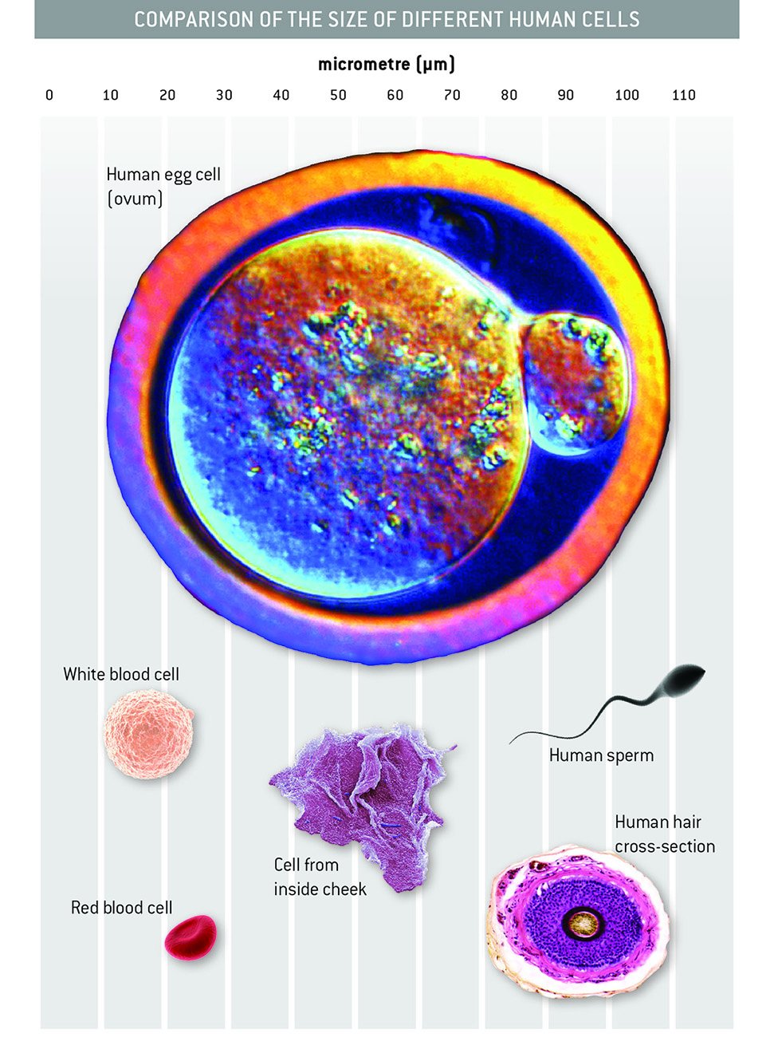

6 For each cell, determine how big it is using the scale on the chart and write your answer below. You must measure from left to right, i.e. the length or diameter of the cell.

a Human egg cell (ovum):

b White blood cell:

c Red blood cell:

d Cell from inside cheek:

e Human sperm cell:

f Human hair cross-section:

Microbiologists measure the size of cells based on the magnification of the microscope they are looking through. The three images below show cells observed through a microscope.

7 Using the measuring bar below, measure the size of each of the following cells.

|  |  |  |
| --- | --- | --- |
| SW0109_01361-rf | SW0111_01361-rf | SW0112_01361-r |
| SW0110_01361 | SW0110_01361 | SW0110_01361 |
| Micrometres (μm) | Micrometres (μm) | Micrometres (μm) |

|  |  |  |
| --- | --- | --- |
| Pink cell:    Red cell:    Green cell: | Height of the middle cell:    Width of the middle cell:    Width of any green chloroplast: | Width of a frog egg:    Width of the nucleus (black): |

Student worksheet

6.4 All organisms have cells that specialise

Pages 104–105 and 200–201

Specialised cells

1 Cells are classified into what two main groups?

2 Create a list of the characteristics of these two main groups of cells.

|  |  |
| --- | --- |
| P \_\_\_\_\_\_\_\_\_\_\_\_\_\_\_\_\_\_\_\_\_\_\_\_\_\_\_\_\_\_\_ | E \_\_\_\_\_\_\_\_\_\_\_\_\_\_\_\_\_\_\_\_\_\_\_\_\_\_\_\_\_\_\_ |
|  |  |
|  |  |
|  |  |
|  |  |
|  |  |

3 The following statements about the characteristics of cells in the five kingdoms are wrong. Explain why each statement is wrong.

a Cell walls are found only in Plants.

b Chloroplasts are present in all Protists.

c Ribosomes are absent in the cells of all kingdoms.

d All kingdoms have multicellular organisms.

e All kingdoms have cells that contain a nucleus.

f Large vacuoles are present only in plants.

g Mitochondria are present in Monera.

h Only some cells have genetic material.

Extend your understanding

4 State which kingdom the following cells belong to.

|  |  |
| --- | --- |
| SW0614_00951-r | SW0615_00951-rm |
| SW0616_00951-r | SW0617_00951-r |
| SW0618_00951-rm | SW0619_00951-rm |

Student worksheet

6.5 Bacteria are single celled organisms

Pages 106–107 and 202

Bacteria – kingdom Monera

1 How many cells make up a single bacterial organism?

2 How much non-human life is inside an average adult’s large intestine at any given time?

3 What is a pathogen?

4 What does it mean to be contagious?

5 What is a host?

6 What is a symptom of a disease?

7 What are three possible disease symptoms?

8 What are harmful microbes?

9 What are four types of microbes?

10 For each of the four microbe types identified in question 9, give two examples of each.

11 Are viruses living or non-living?

12 What is the difference between a virus and a cell?

13 Why is it hard for our immune system to fight viruses?

14 What is the process of cell division in bacteria called?

15 Why should your fridge be operated at 4ºC or lower?

16 Why should your food be cooked at 60ºC or higher?

Extend your understanding

17 The following graph shows the number of specific bacterial cells present in a person during a   
one-week period.

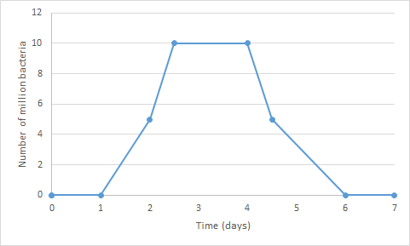

a When was the person producing the most of this bacteria?

b What process was responsible for this growth?

c When did this bacterial growth stop?

d What reason can you give for the bacterial growth stopping?

e At what temperature was this bacteria growing?

Student worksheet

6.6 Eukaryotic cells undergo mitosis

Pages 108–109 and 203

Mitosis

1 What is the purpose of DNA?

2 Where is DNA stored?

3 What must happen before a cell splits to reproduce?

4 What is mitosis?

5 What is the difference between a parent and daughter cell?

6 Draw a diagram to show the process of mitosis.

7 What is cancer caused by?

8 What happens to cells when they reach the end of their life? What is this process called?

9 What is the difference between a mutagen and a carcinogen?

10 What is a tumour?

11 What is a secondary cancer?

12 What are the two types of tumour?

13 What are the characteristics of each type of tumour?

Extend your understanding

14 Tasmanian devils are prone to a life threatening condition called TDFTD (Tasmanian devil facial tumour disease). This disease results in tumours around the face and neck. It can be transmitted from devil to devil due to their aggressive fighting behaviours in which they bite each other around the face.

a What type of tumour causes TDFTD?

b What effect does this tumour have on the Tasmanian devil?

c In most cases, the devils do not die from the cancer itself but from side effects caused by this cancer. Considering the information above, what might two of these effects be?

d Why is Tasmania creating an insurance population?

e Why would it be beneficial to cull the infected population?

Student worksheet

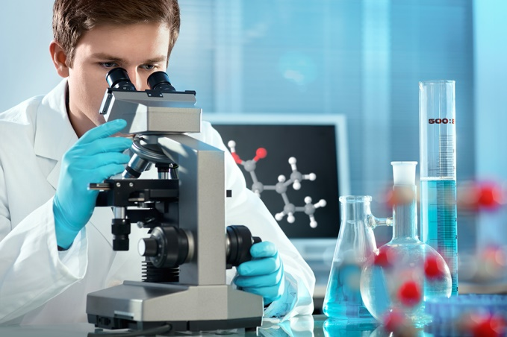6.7 Fungal cells can save lives

Pages 110–111

Using cells to save lives

1 Why were injuries so dangerous in the early 1900s and before?

2 What is a key property of some moulds that makes it essential to medicine?

3 What discovery was made in 1928 and who made this discovery?

4 Why is it said that this discovery was an accident?

5 How does penicillin stop bacterial growth/infection?

6 Which two scientists developed a method to isolate penicillin?

7 What were the outcomes of the initial experiment used to determine if penicillin had been isolated?

8 Use your knowledge to determine why human trials were conducted after animal trials.

9 What were the scientists rewarded with for the isolation of penicillin for medicinal use?

10 Use the penicillin timeline on page 111 of your student book to state the event that occurred in the following years.

a 1000

b 1870

c 1871

d 1897

e 1922

f 1928

g 1930s

Extend your understanding

11 The case of penicillin is a perfect example of the scientific method.

a State the problem that Fleming was trying to overcome.

b What would Fleming’s hypothesis have been, regarding the mould and bacteria?

c What results did he obtain from his research that supported his hypothesis?

12 Analyse the experiment conducted on mice by Florey and Chain and answer the following questions.

a State the problem that Florey and Chain were trying to overcome.

b What would Florey and Chain’s hypothesis have been, regarding penicillin and streptococcal bacteria?

c What results did they obtain from their research that supported their hypothesis?

d How were their findings used to change the course of history?